Fractional Numerals

✅ Definition:
# Source: AI Source: Provided by: [Data Path: Persons Table -> ID Column: 1, Name_En Column: Motasem Essam] -> From: [Chatgpt (GPT-4-turbo)] on [7/28/2025]
Fractional numerals (also called fractional numbers) express part of a whole.
They answer the question: "What part?" or "How much of a whole?"

🧩 Examples of Fractional Numerals:
# Source: AI Source: Provided by: [Data Path: Persons Table -> ID Column: 1, Name_En Column: Motasem Essam] -> From: [Chatgpt (GPT-4-turbo)] on [7/28/2025]
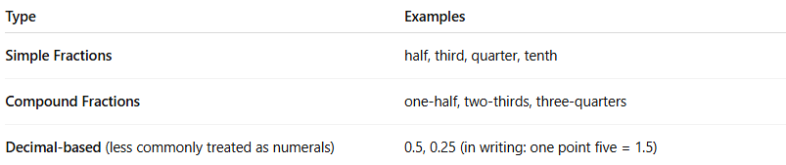
Type | Examples
Simple Fractions | half, third, quarter, tenth
Compound Fractions | one-half, two-thirds, three-quarters
Decimal-based (less commonly treated as numerals) | 0.5, 0.25 (in writing: one point five = 1.5)

✏️ Examples in Sentences:
# Source: AI Source: Provided by: [Data Path: Persons Table -> ID Column: 1, Name_En Column: Motasem Essam] -> From: [Chatgpt (GPT-4-turbo)] on [7/28/2025]
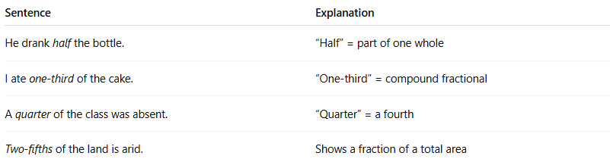
Sentence | Explanation
He drank half the bottle. | “Half” = part of one whole
I ate one-third of the cake. | “One-third” = compound fractional
A quarter of the class was absent. | “Quarter” = a fourth
Two-fifths of the land is arid. | Shows a fraction of a total area

📌 Grammatical Functions:
# Source: AI Source: Provided by: [Data Path: Persons Table -> ID Column: 1, Name_En Column: Motasem Essam] -> From: [Chatgpt (GPT-4-turbo)] on [7/28/2025]
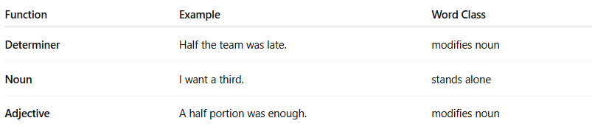
Function | Example | Word Class
Determiner | Half the team was late. | modifies noun
Noun | I want a third. | stands alone
Adjective | A half portion was enough. | modifies noun

🔍 Properties of Fractional Numerals:
# Source: AI Source: Provided by: [Data Path: Persons Table -> ID Column: 1, Name_En Column: Motasem Essam] -> From: [Chatgpt (GPT-4-turbo)] on [7/28/2025]
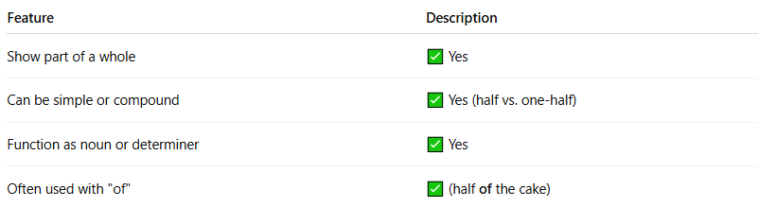
Feature | Description
Show part of a whole | ✅ Yes
Can be simple or compound | ✅ Yes (half vs. one-half)
Function as noun or determiner | ✅ Yes
Often used with "of" | ✅ (half of the cake)

⚠️ Note:
# Source: AI Source: Provided by: [Data Path: Persons Table -> ID Column: 1, Name_En Column: Motasem Essam] -> From: [Chatgpt (GPT-4-turbo)] on [7/28/2025]
- Fractional ≠ Cardinal:
  - “Three” = exact number
  - “Three-fourths” = part of something
- Fractional ≠ Ordinal:
  - “Third” = position
  - “One-third” = part of a whole

🧠 Summary:
# Source: AI Source: Provided by: [Data Path: Persons Table -> ID Column: 1, Name_En Column: Motasem Essam] -> From: [Chatgpt (GPT-4-turbo)] on [7/28/2025]
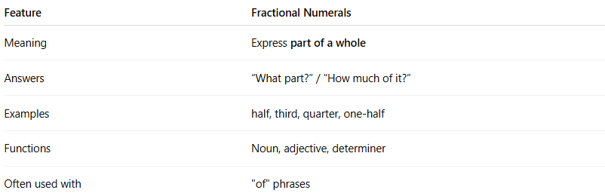
Feature | Fractional Numerals
Meaning | Express part of a whole
Answers | “What part?” / “How much of it?”
Examples | half, third, quarter, one-half
Functions | Noun, adjective, determiner
Often used with | "of" phrases

